Pokhara University

Level: Bachelor | Semester – Spring | Year : 2007
Programme: BE |  | Full Marks: 100
Course: Control System |  | Time : 3hrs.

Candidates are required to give their answers in their own words as far as practicable.
The figures in the margin indicate full marks.

Attempt all the questions.

 | - What do you mean by feedback system? Explain with suitable example.  - Obtain the mathematical equation and force voltage analogy of the mechanical system shown below.  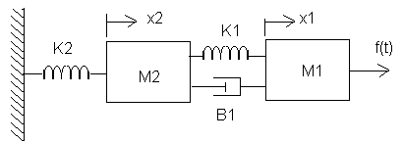 | 7  8
 | - Obtain the transfer function of the system using block diagram reduction technique.  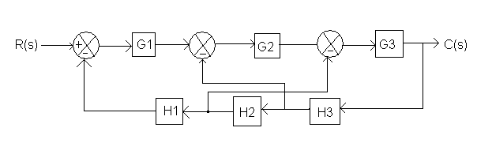  - Consider the unit step response of a unity feedback control system whose open loop transfer function is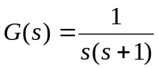. Obtain the rise time, peak time, maximum overshoot and settling time. | 8  7
 | - For the following system to meet he requirements of K_{V} = 10 sec⁻¹ and maximum overshoot of 20%, determine the value of K and T.  G(s) = K/ {s(s+2)} ; H(s) = Ts + 3  - Using Routh criteria, calculate the range of K for the system to be stable, for a unity feedback control system, characterized by the open loop transfer function | 8  7
 | Sketch the root locus for 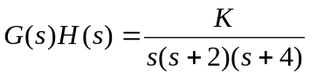 and evaluate the value of K at the point where the root loci crosses the imaginary axis. Also, determine the value of K so that the dominant pair of complex poles of the system has a damping ratio of 0.5. | 15
 | - Sketch the Bode plot for the transfer function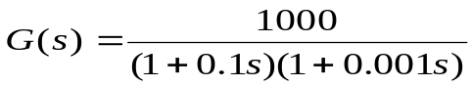. Determine the gain margin, phase margin and the system stability  - Sketch the polar plot of the system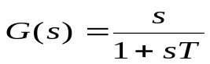. | 9  6
 | Design a suitable lag compensating network for 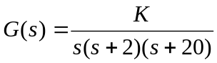 to meet the following specifications Kv = 20 sec⁻¹and P.M ≥ 35°. | 15
 | Write short notes on (Any Two):  - Steady state error  - State transition matrix  - Root location and stability | 2×5

